Bluetooth APP User Manual
Version: V1.0
Date: April 2016

Due to constant update of the product, ZKTeco neither promises that data in this document is consistent with the actual product, nor assumes any liability for any dispute that arises due to inconsistency between actual technical parameters and data in this document. Data in this document is subject to change without any prior notice.

Applicable devices: Bluetooth-enabled access control machines or infrared switches
Scan the following QR code with your mobile phone, and download and install the APP.
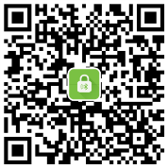
Mobile phone requirement for APP installation: Android OS later than version 4.3, compliant with the Bluetooth protocol later than 4.0; iOS later than 7.1, devices later than iPhone 4S
1. Connecting the APP to the Bluetooth Device

Preparation: Enable the Bluetooth function on the mobile phone, and power on the Bluetooth device.
Start the APP. On the homepage of the APP, tap to access the device list page. The APP will automatically search the device. Alternatively, you can tap to search the device. Then, tap the searched device name to connect to the device.
Note: When the APP on the mobile phone is being connected to the Bluetooth device, you cannot perform any operation on the Bluetooth device. In addition, the connected Bluetooth device cannot be connected to the APP on any other mobile phone.
You can tap the connected device to disconnect the APP from this device.
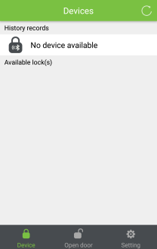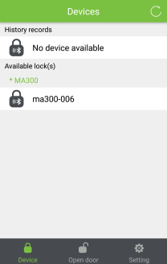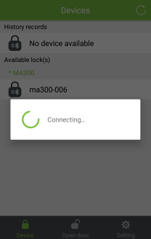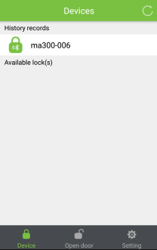
You do not need to enter a password to connect to a Bluetooth access control machine
2. Registering the Administrator or Modifying the Connection Password

After the device is connected, tap Setting > Supervisor password mode on your mobile phone to register the administrator for the Bluetooth access control machine.
Administrator: The administrator must be registered on the APP to manage user rights, for example, deleting/adding users, setting access control parameters, and binding the mobile phone.
Note:An administrator registered on the APP is the APP administrator, but not the device administrator.
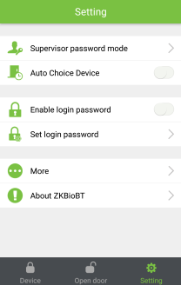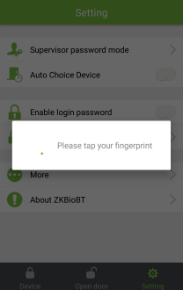
The mobile phone can be bound only after the administrator is registered. (After this step is completed, the APP can be used to open the door.)
After the administrator is registered, tap Open door and then , enter and verify the administrator's fingerprint or card, and bind the mobile phone. After the mobile phone is bound successfully, the door can be opened.
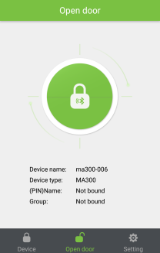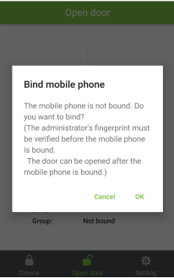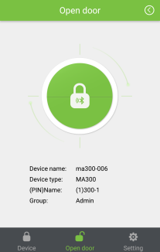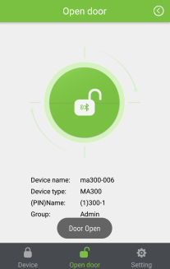
For a Bluetooth infrared switch, you can tap Device settings > Set connection password to modify the connection password.
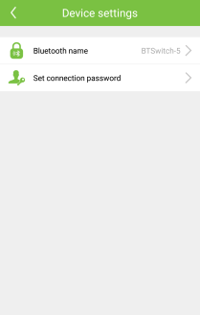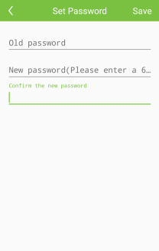
Note: If you forget the connection password after modifying the password of the Bluetooth infrared switch, you can press and hold the reset button of the Bluetooth infrared switch for 5 seconds to restore the default connection password 123456.
3. User Information
After registering the administrator, tap Setting > Supervisor password mode to verify the administrator. After the verification succeeds, is displayed in the upper-right corner of the homepage. Tap > User > , and enter the user information to add a user.
You can tap the added user to edit the user information, or slide to the left to delete this user.
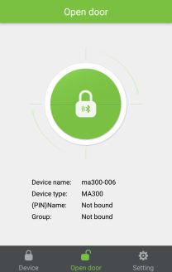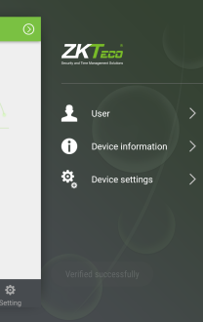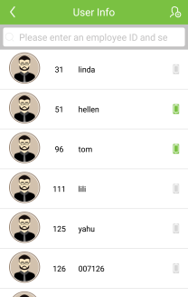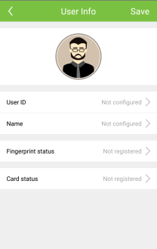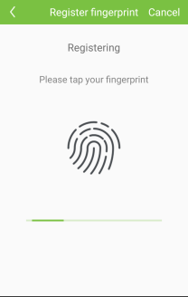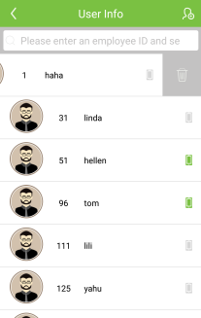
4. Device Settings

After registering the administrator, tap Setting > Supervisor password mode to verify the administrator. After the verification succeeds, is displayed in the upper-right corner of the homepage. Tap > Device settings. For a Bluetooth access control device, you can set the open time and magnetometer mode
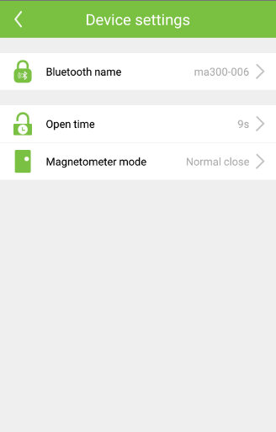
Open time: It specifies the time during which the electric lock is in open state.
Magnetometer mode: Three magnetometer modes are available: normal open, normal close, and no magnetometer. no magnetometer indicates that the magnetometer switch is not used; normal open indicates that the state is normal if the door is opened; normal close indicates that the state is normal if the door is closed.
Settings of the preceding parameters are subject to the product model that you are using.
5. Setting the APP Login Password

Tap Set login password, enter the password, and slide Enable login password to the right. Next time when you log in to the APP, the login password must be verified.
To re-configure the login password, tap Set login password, enter the old password, and enter the new password.
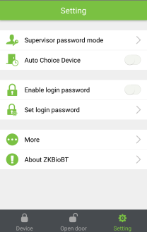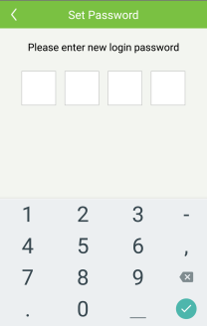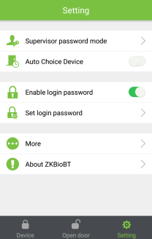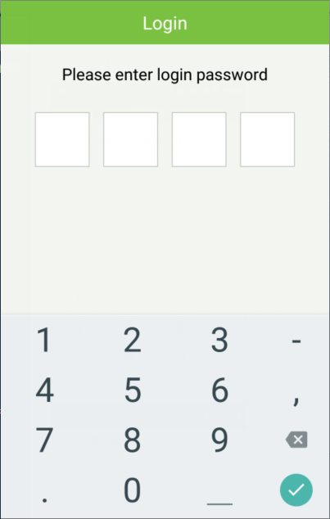
6. Device Information

After registering the administrator, tap Setting > Supervisor password mode to verify the administrator. After the verification succeeds, is displayed in the upper-right corner of the homepage. Tap > Device information. The basic device information and the storage capacity are displayed.
